TREE QUESTIONS

Table of Contents
Theory 3
What is Tree data structure? 3
What are components of tree? 3
Binary Tree 4
Tree traversal 4
Binary Search Tree 5
Use cases of Tree and its use in system design 5
Array representation of Binary Tree 6
Important Codes 7
Binary Search Tree Implementation: 7
Traversals: 8
Level Order Traversal: 9
Morris Traversal: 10
LEVEL 1: Armature 14
1. Sum of binary tree 14
2. Search a node in BST 14
3. Count Leaves in binary tree 14
4. N-Ary Tree postorder traversal 14
5. Maximum Depth of binary tree 14
6. Height of binary tree 14
7. Convert a BST to tree with only right nodes. 14
8. Check if two binary trees are same or not. 14
9. Range sum of bst 14
10. Average of levels in binary tree. 14
11. Sum of left leaves 14
12. Invert a binary tree 14
LEVEL 2: Pro 15
1. Merge two binary trees. 15
2. Sorted array to BST 15
3. Binary Tree tilt 15
4. Diameter of binary tree 15
5. Subtree of another tree 15
LEVEL 3: Legend 16
SOLUTIONS: 17
LEVEL 1: 17
LEVEL 2: 24

Theory

What is Tree data structure?
A tree is a hierarchical data structure that starts with a root node and consists of connected nodes. It organizes elements in a parent-child relationship, where each node can have multiple children. It is widely used for representing hierarchical relationships and enables efficient searching, insertion, and deletion operations.

What are components of tree?
- Root: A tree has a unique node called the root, which serves as the starting point of the tree. All other nodes in the tree are descendants of the root.
- Nodes: A tree consists of nodes that are connected by edges. Each node can have zero or more child nodes. Nodes other than the root are referred to as internal nodes, while nodes without any children are called leaf nodes or leaves.
- Edges: Edges are the connections between nodes in a tree. They represent the relationships between the nodes. Each node (except the root) has exactly one incoming edge from its parent node, and it may have zero or more outgoing edges to its child nodes.
- Parent and Child Nodes: Each node in a tree (except the root) has a unique parent node, which is the node directly above it. The parent node is connected to its child nodes through edges. Conversely, child nodes are the nodes directly below a parent node.
- Ancestors and Descendants: An ancestor of a node is any node that exists on the path from the root to that node, excluding the node itself. A descendant of a node is any node that can be reached by following edges from the node, again excluding the node itself.
- Path: A path in a tree is a sequence of nodes connected by edges. It represents the traversal from one node to another within the tree.
- Depth and Height: The depth of a node is the length of the path from the root to that node. The height of a tree is the maximum depth of any node in the tree. The height represents the length of the longest path from the root to a leaf node.
- Subtree: A subtree is a portion of the tree that consists of a node and all its descendants, including their child nodes and their child nodes, and so on.
- Degree: The degree of a node is the number of its child nodes. A node with a degree of zero is a leaf node, while a node with a degree greater than zero is an internal node.
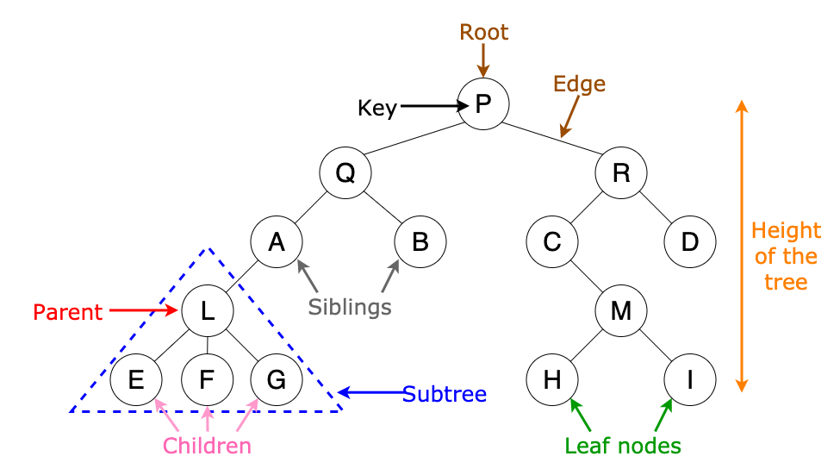

Binary Tree
A binary tree is a tree data structure where each node can have at most two children, the left child and the right child.
Some types of binary trees are:-
- Full Binary Tree: A full binary tree is a binary tree in which every node has either 0 or 2 children. In other words, every level of the tree is completely filled, except for the last level, which may or may not be full.
- Complete Binary Tree: A complete binary tree is a binary tree in which all levels are completely filled, except possibly for the last level, which is filled from left to right. It ensures that the nodes are as balanced as possible.
- Perfect Binary Tree: A perfect binary tree is a binary tree in which all levels are completely filled with maximum possible nodes. It is a type of complete binary tree with exactly 2^h - 1 nodes, where h is the height of the tree.
- Balanced Binary Tree: A balanced binary tree is a binary tree in which the difference in height between the left and right subtrees of any node is at most 1. It ensures that the height of the tree remains relatively small, resulting in efficient operations.
- Degenerate (or Pathological) Binary Tree: A degenerate binary tree is a binary tree in which each parent node has only one child (either left or right). It essentially becomes a linked list.

Tree traversal
- Preorder traversal ( root, left , right)
- Inorder traversal ( left, root, right)
- Postorder traversal ( left, right, root)
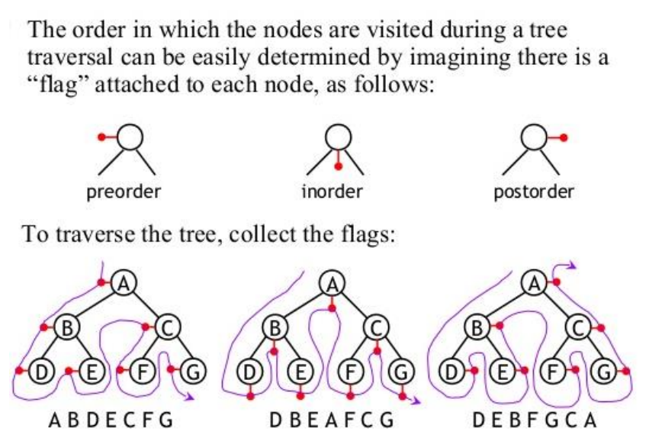

Binary Search Tree
A binary search tree is a type of binary tree that follows a specific ordering of the nodes. In a binary search tree, the left child of a node contains values that are less than the parent node, and the right child contains values that are greater than the parent node. This ordering property allows for efficient searching, insertion, and deletion operations.
For BST inorder traversal gives numbers in ascending order.

Use cases of Tree and its use in system design
- File System: Trees are widely used to represent file systems in operating systems. Each directory is represented as a node in the tree, with subdirectories and files as its children.
- Routing Algorithms: Trees are employed in routing algorithms used in networking and telecommunications systems. Examples include the spanning tree protocol (STP) for network redundancy and the hierarchical routing protocol used in the Internet's Border Gateway Protocol (BGP) to organize routing tables.
- Data Compression: Huffman coding is a popular technique for data compression that involves constructing a binary tree where the leaves represent characters and their frequency of occurrence. The resulting tree is used to encode the data in a way that minimizes the amount of storage required.
- Compiler Design: In compiler design, a syntax tree is used to represent the structure of a program.
- Database Indexing: B-trees and other tree structures are used in database indexing to efficiently search for and retrieve data.
- User Interfaces: Trees are utilized in the design of graphical user interfaces (GUIs) to represent the hierarchy of UI elements. This allows for efficient event handling, layout management, and navigation within the UI.

Binary Search Tree Implementation:

class Node:
def __init__(self,data):
self.data = data
self.left = None
self.right = None

class BST:
def __init__(self):
self.root = None

def insert(self,data):
def insert_recursive(node,data):
if node is None:
return Node(data)
if data < node.data:
node.left = insert_recursive(node.left,data)
else:
node.right = insert_recursive(node.right,data)
return node
self.root = insert_recursive(self.root, data)

def inorder(self):
def inorder_traversal(node):
if node is not None:
inorder_traversal(node.left)
print(node.data,end=" ")
inorder_traversal(node.right)

inorder_traversal(self.root)

def search(self,data):
def search_recursive(node,data):
if node is None:
return False
if node.data == data:
return True
if data < node.data:
return search_recursive(node.left,data)
else:
return search_recursive(node.right,data)

return search_recursive(self.root,data)

bst = BST()
bst.insert(3)
bst.insert(5)
bst.insert(0)
bst.insert(9)
bst.inorder()
print(bst.search(9))

Array representation of Binary Tree
- If parent is in k th position:
- Left child – 2K position
- Right child – 2k+1 position

- If child is in k th position:
Parent position = floor(k/2)

- Size of array needed to represent a binary tree of height h
= Maximum number of nodes possible in binary tree = 2^{h}-1
- For n nodes:- complete binary tree will have minimum height , hence will require least size of array to represent
- Null nodes are also considered in array representation.

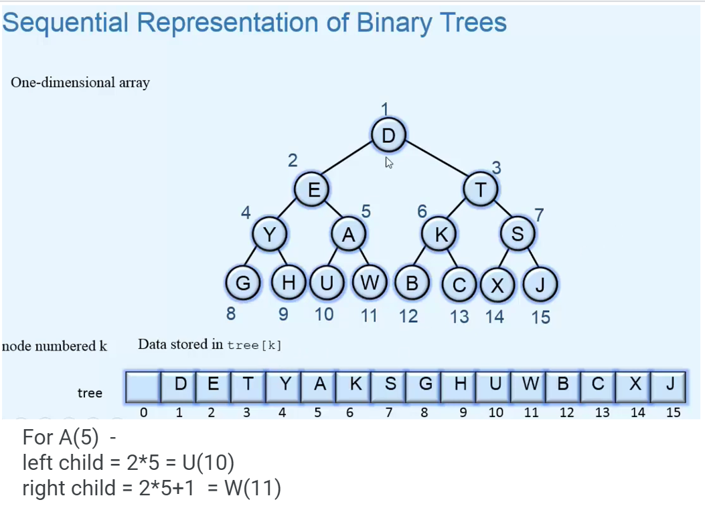

LEVEL 1: Armature

Sum of binary tree
Link: https://www.geeksforgeeks.org/problems/sum-of-binary-tree/1

Search a node in BST
Link: https://www.geeksforgeeks.org/problems/search-a-node-in-bst/1

Count Leaves in binary tree
Link: https://www.geeksforgeeks.org/problems/count-leaves-in-binary-tree/1

N-Ary Tree postorder traversal
Link: https://leetcode.com/problems/n-ary-tree-postorder-traversal/

Maximum Depth of binary tree
Link: https://leetcode.com/problems/maximum-depth-of-binary-tree/

Height of binary tree
Link: https://www.geeksforgeeks.org/problems/height-of-binary-tree/1

Convert a BST to tree with only right nodes.
Link: https://leetcode.com/problems/increasing-order-search-tree/description/

Check if two binary trees are same or not.
Link: https://leetcode.com/problems/same-tree/description/

Range sum of bst
Link: https://leetcode.com/problems/range-sum-of-bst/description/

Average of levels in binary tree.
Link: https://leetcode.com/problems/average-of-levels-in-binary-tree/description/

Sum of left leaves
Link: https://leetcode.com/problems/sum-of-left-leaves/description/

Invert a binary tree
Link: https://leetcode.com/problems/invert-binary-tree/

LEVEL 2: Pro

Merge two binary trees.
Link: https://leetcode.com/problems/merge-two-binary-trees/description/

Sorted array to BST
Link: https://leetcode.com/problems/convert-sorted-array-to-binary-search-tree/description/

Binary Tree tilt
Link: https://leetcode.com/problems/binary-tree-tilt/description/

Diameter of binary tree
Link: https://leetcode.com/problems/diameter-of-binary-tree/description/

Subtree of another tree
Link: https://leetcode.com/problems/subtree-of-another-tree/description/

Sum of Nodes with Even-Valued Grandparent
Link: https://leetcode.com/problems/sum-of-nodes-with-even-valued-grandparent/

Balance a binary search tree
Link: https://leetcode.com/problems/balance-a-binary-search-tree/

LEVEL 3: Legend

Topic Wise Tree Questions

Red ones: Can use for teaching, others can be given for practice
Black question in video, add extra similar question to practice( and in solutions as connected problem, plus end of section as additional problems to practice(small list type)

Pattern 1 — Tree Traversals
- Binary Tree Preorder Traversal (144) LeetCode Easy
- Binary Tree Inorder Traversal (94) LeetCode Easy
- Binary Tree Postorder Traversal (145) LeetCode Easy
- Binary Tree Level Order Traversal (102) LeetCode Medium
- Binary Tree Level Order Traversal II (107) LeetCode Medium
- Binary Tree Zigzag Level Order Traversal (103) LeetCode Medium
- Average of Levels in Binary Tree (637) LeetCode Easy
- N-ary Tree Preorder Traversal (589) LeetCode Easy
- N-ary Tree Postorder Traversal (590) LeetCode Easy
- N-ary Tree Level Order Traversal (429) LeetCode Medium
- Path Sum (112) LeetCode 🟢 Easy
- Path Sum II (113) LeetCode 🟡 Medium
- Binary Tree Paths (257) LeetCode 🟢 Easy
- Sum Root to Leaf Numbers (129) LeetCode 🟡 Medium

Pattern 2 — Tree Properties
- Maximum Depth of Binary Tree (104) LeetCode 🟢 Easy
- Minimum Depth of Binary Tree (111) LeetCode 🟢 Easy
- Maximum Depth of N-ary Tree (559)LeetCode 🟢 Easy
- Balanced Binary Tree (110) LeetCode 🟢 Easy
- Same Tree (100) LeetCode 🟢 Easy
- Symmetric Tree (101) LeetCode 🟢 Easy
- Invert Binary Tree (226) LeetCode 🟢 Easy

Pattern 3 — BST Properties
- Search in a BST (700) LeetCode 🟢 Easy
- Insert into a BST (701) LeetCode 🟡 Medium
- Validate Binary Search Tree (98) LeetCode 🟡 Medium
- Range Sum of BST (938) LeetCode 🟢 Easy
- Minimum Absolute Difference in BST (530) LeetCode 🟢 Easy
- Kth Smallest Element in a BST (230) LeetCode 🟡 Medium
- BST Iterator (173) LeetCode 🟡 Medium
- Delete Node in a BST (450) LeetCode 🟡 Medium
- Convert BST to Greater Tree (538) LeetCode 🟡 Medium
- Trim a BST (669) LeetCode 🟡 Medium
- Recover Binary Search Tree (99) LeetCode 🟡 Medium

Pattern 4 — Advanced DFs
- Diameter of Binary Tree (543) LeetCode 🟢 Easy
- Count Good Nodes in Binary Tree (1448) LeetCode 🟡 Medium
- Longest Univalue Path (687) LeetCode 🟡 Medium
- Maximum Width of Binary Tree (662) LeetCode 🟡 Medium
- Serialize and Deserialize BST (449) LeetCode 🟡 Medium solution
- Find Duplicate Subtrees (652) LeetCode 🟡 Medium
- Lowest Common Ancestor of a Binary Tree (236) LeetCode 🟡 Medium
- Lowest Common Ancestor of a BST (235) LeetCode 🟡 Medium

Pattern 5 — Tree Views
- Binary Tree Right Side View (199) LeetCode 🟡 Medium
- Find Bottom Left Tree Value (513) LeetCode 🟡 Medium
- Boundary Traversal of Binary Tree GeeksforGeeks 🟡 Medium
- Top View of Binary Tree GeeksforGeeks 🟡 Medium
- Bottom View of Binary Tree GeeksforGeeks 🟡 Medium

Pattern 6— Tree Construction and modification
- Convert Sorted Array to BST (108) LeetCode 🟢 Easy
- Construct Binary Tree from Preorder and Inorder Traversal (105) LeetCode 🟡 Medium
- Construct Binary Tree from Inorder and Postorder Traversal (106) LeetCode 🟡 Medium
- Convert Sorted List to BST (109) LeetCode 🟡 Medium
- Convert Binary Tree to Doubly Linked List GeeksforGeeks 🟡
- Flatten Binary Tree to Linked List (114) LeetCode 🟡 Medium
- Populating Next Right Pointers in Each Node (116) LeetCode 🟡 Medium

Pattern 7— DP on Trees
- Unique Binary Search Trees (96) LeetCode 🟡 Medium
- Binary Tree Maximum Path Sum (124) LeetCode 🔴 Hard (DP on tree)
- House Robber III (337) LeetCode 🟡 Medium(DP on tree)
- Distribute Coins in Binary Tree (979) LeetCode 🟡 Medium(DP on tree)
- Binary Tree Cameras (968) LeetCode 🔴 Hard(DP on tree)

SOLUTIONS:

LEVEL 1:

# while using global array or variable, always remember to clear it first before use. Else if we run code for more than one output in global array answers get appended for all test cases.
# we can also write this without the use of global variable, as explained in method 2 and 3.

#Method 1 (use of global variable)
class Solution:
res=[]
def inOrder(self,root):
if root is None:
return
self.inOrder(root.left)
self.res.append(root.val)
self.inOrder(root.right)

def inorderTraversal(self, root: Optional[TreeNode]) -> List[int]:
self.res.clear() #clear the data
self.inOrder(root)
return self.res

#Method 2 (without global variable)
class Solution:
def inorderTraversal(self, root: Optional[TreeNode]) -> List[int]:
res = []
if root is None:
return res
res+=self.inorderTraversal(root.left)
res+=[root.val]
res+=self.inorderTraversal(root.right)
return res

# Method 3: One liner
class Solution:
def inorderTraversal(self, root: Optional[TreeNode]) -> List[int]:
return self.inorderTraversal(root.left) + [root.val] + self.inorderTraversal(root.right) if root else []

#For Preorder
class Solution:
def preorder_traversal(self, root: Optional[TreeNode]) -> List[int]:
return [root.val]+self.preorder_traversal(root.left) + self.preorder_traversal(root.right) if root else []

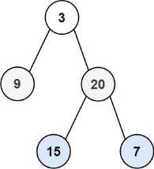
Level Order Traversal:
Problem: so if input is given tree root = [3,9,20,null,null,15,7]
Output should be = [[3], [9,20], [15,7]]
Ques: https://leetcode.com/problems/binary-tree-level-order-traversal/

Since we need to process the tree level by level, BFS is the natural fit — unlike DFS (which dives deep first), BFS explores all nodes at the current depth before moving to the next depth. A queue naturally supports this "process in the order added" behavior (FIFO).

from collections import deque

class Solution:
def levelOrder(self, root: Optional[TreeNode]) -> List[List[int]]:
q = deque([root]) # queue starts with just the root node (could be None if tree is empty)
ans = [] # final result: list of levels, each level is a list of values

while q:
q_len = len(q) # snapshot: exactly how many nodes belong to THIS level

level = [] # values collected for the current level

for _ in range(q_len): # process exactly q_len nodes — i.e., only this level's nodes
node = q.popleft()

if node: # guard against None (relevant for the initial root=None case,
# since we always push both children even if they don't exist)
level.append(node.val)
q.append(node.left)
q.append(node.right)

if level: # guards against trailing empty levels from None children, and empty root
ans.append(level)

return ans

Key intuition: By snapshotting the queue's length (q_len) at the start of each round, we know exactly how many nodes belong to the current level — even though we're actively pushing next-level nodes (children) into the same queue during that round. This is the trick that lets a single queue handle multiple levels cleanly, without needing separate queues per level.

Why none children are pushed but guarded against: This implementation always pushes node.left and node.right even if they're None (leaf nodes have no real children). This keeps the code simple/uniform (no need for extra if node.left: checks before pushing), but means the queue will contain some None entries that get filtered out by the if node: check when popped. It's a small trade-off: slightly more queue churn, in exchange for simpler push logic.

- Sum of binary tree

#Approach 1: using seperate inorder traversal method and using global variable
class Solution:
def sumBT(self, root):
#run inorder traversal and get sum of all
def inorder(root):
global ans
if root is not None:
inorder(root.left)
ans+=root.data
inorder(root.right)

global ans
ans=0
inorder(root)
return ans

#Approach 2: using just plain recursion without global keyword
class Solution:
def sumBT(self, root):
if root is None:
return 0

l=self.sumBT(root.left)
r=self.sumBT(root.right)
return root.data + l + r

#Appproach 3(shorter)
class Solution:
def sumBT(self, root):
return root.data+self.sumBT(root.left)+self.sumBT(root.right) if root else 0

- Search a node in BST

class BST:
def search(self, node, x):
if node is None:
return False
if node.data==x:
return True
if node.data>x:
return self.search(node.left,x)
return self.search(node.right,x)

- Count Leaves in binary tree

class Solution:
def countLeaves(self, root):
if root is None:
return 0
#Means it is leave, so no need to iterate further subtree of it
if root.left is None and root.right is None:
return 1

return self.countLeaves(root.left) + self.countLeaves(root.right)

- N-Ary tree postorder traversal

class Solution:
def postorder(self, root: 'Node') -> List[int]:
#postorder:left right root
def helper(node):
if node:
for temp in node.children:
helper(temp)
ans.append(node.val)

global ans
ans=[]
helper(root)
return ans

- Maximum depth of binary tree
class Solution:
def maxDepth(self,root):
if root is None:
return 0
if not root.left and not root.right:
return 1
l = self.maxDepth(root.left)
r = self.maxDepth(root.right)
return 1+max(l,r)

#Approach 2
def maxDepth(self, root):
if root is None:
return 0
return 1 + max(self.maxDepth(root.left), self.maxDepth(root.right))

- Height of binary tree
class Solution:
def height(self, root):
if root is None:
return 0
#this is end condition but since if we return 1 from here, it will be count of nodes
#to get edge count (edge count = node count-1) , so return 0
if not root.left and not root.right:
return 0

l = self.height(root.left)
r = self.height(root.right)
return 1+max(l,r)

- Convert BST to inorder tree with only right node
# first get inorder traversal create a new tree and add all values to right subtree
class Solution:
def increasingBST(self, root: TreeNode) -> TreeNode:
def inorder(root):
return inorder(root.left)+[root.val]+inorder(root.right) if root else []

inorder_trav = inorder(root)
temp=TreeNode()
ans=temp
for val in inorder_trav:
temp.right = TreeNode(val)
temp = temp.right

return ans.right

- Same tree

class Solution:
def isSameTree(self, p: Optional[TreeNode], q: Optional[TreeNode]) -> bool:
if p is None and q is None:
return True
if (p is None) or (q is None):
return False
if p.val!=q.val:
return False
return self.isSameTree(p.left,q.left) and self.isSameTree(p.right,q.right)

Approach 2

class Solution:
def isSameTree(self, p: Optional[TreeNode], q: Optional[TreeNode]) -> bool:
#while q for i in range q, popleft current one, popleft from other one, if they arent #equal, break add left if left, add right. same for other one
q1 = deque([p])
q2 = deque([q])
while q1:
if len(q1) != len(q2):
return False
for i in range(len(q1)):
curr1 = q1.popleft()
curr2 = q2.popleft()

if not curr1 and not curr2:
continue
if not curr1 or not curr2:
return False
if curr1.val != curr2.val:
return False

q1.append(curr1.left)
q1.append(curr1.right)
q2.append(curr2.left)
q2.append(curr2.right)

return True

- Range sum of bst
Solution
class Solution:
def rangeSumBST(self, root: Optional[TreeNode], low: int, high: int) -> int:
def travel(root):
global ans
if (root is None) :
return
else:
if root.val>=low and root.val<=high:
ans+=root.val
if root.val >low:
travel(root.left)
if root.val <high:
travel(root.right)
global ans
ans=0
travel(root)
return ans

Approach 2: without global value
class Solution:
def rangeSumBST(self, root: Optional[TreeNode], low: int, high: int) -> int:
if root is None:
return 0
if root.val<low:
return self.rangeSumBST(root.right,low,high)
if root.val>high:
return self.rangeSumBST(root.left,low,high)
return root.val+self.rangeSumBST(root.left,low,high)+self.rangeSumBST(root.right,low,high)

- Average of levels in binary tree
#Approach: iterate normally but maintain level
#res[level]= [sum_of_all_values_in_level , count_of_elemets_in_level]
class Solution:
def averageOfLevels(self, root: Optional[TreeNode]) -> List[float]:
res=[] #[[level_sum,count_of_elements]]
def dfs(node, lvl=0):
if not node:
return
if len(res)<lvl+1: #means for level+1, there is no res, so add
res.append([0,0])
dfs(node.left, lvl+1)
res[lvl][0]+=node.val
res[lvl][1]+=1
dfs(node.right, lvl+1)

dfs(root)
return[i/k for i,k in res]
#Approach 2: using breadth level traversal
from collections import deque
class Solution:
def averageOfLevels(self, root: Optional[TreeNode]) -> List[float]:
ans=[]
queue = deque()
queue.append(root)
while(queue):
temp = 0
l = len(queue)

for i in range(l):
t = queue.popleft()
temp+=t.val
if t.left:
queue.append(t.left)
if t.right:
queue.append(t.right)

ans.append(temp/l)

return ans

- Sum of left leaves

class Solution:
def sumOfLeftLeaves(self, root: Optional[TreeNode]) -> int:
def leftSum(node,isLeft):
if node:
if isLeft and (not node.left and not node.right):
self.ans+=node.val
leftSum(node.left,True)
leftSum(node.right,False)

#in place of global can use self also
self.ans=0
leftSum(root,False) #if single node is there, it is not consider left leaf
return self.ans

- Invert a Binary tree

class Solution:
def invertTree(self, root: Optional[TreeNode]) -> Optional[TreeNode]:
if root:
v1 = self.invertTree(root.left)
v2 = self.invertTree(root.right)
root.left = v2
root.right = v1
return root

easier way
class Solution:
def invertTree(self, root: Optional[TreeNode]) -> Optional[TreeNode]:
if root is None:
return root
else:
root.left , root.right = self.invertTree(root.right) , self.invertTree(root.left)
return root

LEVEL 2:

- Merge two binary tree
class Solution:
def mergeTrees(self, root1: TreeNode, root2: TreeNode) -> TreeNode:
if root1 is None:
return root2
if root2 is None:
return root1
root1.val = root1.val + root2.val
root1.left = self.mergeTrees(root1.left,root2.left)
root1.right = self.mergeTrees(root1.right,root2.right)
return root1

- Sorted Array to binary Search tree
Solution


class Solution:
def sortedArrayToBST(self, nums: List[int]) -> Optional[TreeNode]:
def helper(l,r):
if l>r:
return
else:
m = (l+r)//2
root = TreeNode(nums[m])
root.left = helper(l,m-1)
root.right = helper(m+1,r)
return root
return helper(0,len(nums)-1)

- Binary tree tilt
Solution

class Solution:
def findTilt(self, root: TreeNode) -> int:
def helper(root):
if not root: return 0
lv, rv = helper(root.left), helper(root.right)
self.ans += abs(lv - rv)
return root.val + lv + rv #This gives sum of given subtree

self.ans = 0
helper(root)
return self.ans

- Diameter Of Binary tree
Solution

def diameterOfBinaryTree(self, root):

def recurse(node):
if not node: return 0
left, right = recurse(node.left), recurse(node.right)
self.result = max(self.result, left+right)
return 1 + max(left, right)

self.result = 0
recurse(root)
return self.result

Similar way try to code for finding height of binary tree.

- Subtree of another tree

class Solution:
def isSubtree(self, root: Optional[TreeNode], subRoot: Optional[TreeNode]) -> bool:
if subRoot == None :
return True
if root == None :
return False
if self.same(root , subRoot):
return True
return self.isSubtree(root.left , subRoot) or self.isSubtree(root.right , subRoot)

#This is code to check if one tree is equal to other
#check root vals and left and right subtree vals, can't do r==s(this don't work)
def same(self , r , s):
if r == None and s == None :
return True
if r and s and r.val == s.val:
return self.same(r.right , s.right) and self.same(r.left , s.left)
return False

- Sum of Nodes with Even-Valued Grandparent
Take variables for parent and grand parent, and whenever a new child is encountered, make current node as parent and existing parent as grandparent.

class Solution:
def sumEvenGrandparent(self, root: Optional[TreeNode]) -> int:
global sum
sum=0

def dfs(node,par,gp):
global sum
if not node:
return
dfs(node.left,node,par)
if gp and gp.val%2==0:
sum += node.val
dfs(node.right,node,par)

dfs(root,None,None)
return sum

Approach 2: handling parent and grandparent value only
class Solution:
def sumEvenGrandparent(self, root: Optional[TreeNode]) -> int:
def doer(root,pvalue,gvalue):
if not root:
return 0
val=root.val if gvalue%2==0 else 0

return val + doer(root.left,root.val,pvalue)+doer(root.right,root.val,pvalue)
return doer(root,-1,-1)

- Balance a Binary Search Tree
Will first get the inorder traversal of existing tree. Now with that inorder traversal, we will start creating a binary tree by taking mid element and placing elements left to mid in left tree and ones present right to mid element to right subtree. Will do this recursively till all elements are placed correctly.

class Solution:
def inorder(self,root):
return self.inorder(root.left) + [root.val] + self.inorder(root.right) if root else []

def constructBinary(self,arr,left,right):
if left>right:
return None
mid = (left+right)//2
parent = TreeNode(arr[mid])
parent.left = self.constructBinary(arr,left,mid-1)
parent.right = self.constructBinary(arr,mid+1,right)
return parent

def balanceBST(self, root: Optional[TreeNode]) -> Optional[TreeNode]:
inorder_arr = self.inorder(root)
parent = self.constructBinary(inorder_arr, 0,len(inorder_arr)-1)
return parent

